

UNIVERSITY OF EASTERN AFRICA BARATON
SCHOOL OF BUSINESS
DEPARTMENT OF INFORMATION SYSTEMS AND COMPUTING
COURSE: INSY 492 – SENIOR PROJECT

STUDENT NAME: KIPKOECH BRIAN

STUDENT ID: SKIPBR2213

COURSE INSTRUCTOR: MR. OMARI DICKSON
SUPERVISOR: DR. VICTOR MONY

PROJECT DESCRIPTION
The Student Research Management System is a web-based application designed to simplify and improve the management of student research projects within an academic institution. The system provides a centralized platform where students can submit research topic proposals, lecturers can review and approve or reject the proposed topics, and supervisors can be assigned to guide students throughout the research process.
Students are allowed to submit up to three research topic proposals and monitor the status of their submissions. Lecturers can review the proposed topics, provide comments, approve or reject them, and assign appropriate supervisors to approved research topics. Supervisors can access the research topics assigned to them, provide feedback, and guide students during the development of their research projects. Students can also upload their final research documents through the system.
The system includes an administrator module that enables administrators to manage user accounts and roles, monitor research topics, view system statistics, and access final student submissions. The system uses role-based access control to ensure that students, lecturers, supervisors, and administrators can only access features relevant to their responsibilities.

OBJECTIVES
To design a student’s research records management system based on student research topics.
To analyze the student research topic selection process.
To develop a research records management system that allows online research topic selection by students and assignment of supervisors.

DETAILED PROCESS FLOW
User Registration and Login
The process begins when a new user creates an account in the system. During registration, the user provides details such as
- Full name
- Email address
- Password
The system validates the information and checks whether the email address already exists. If the details are valid, the password is encrypted using bcrypt, and the user account is stored in the MySQL database.
By default, a newly registered user is assigned the student role. The administrator can later change the user’s role to either lecturer or supervisor.
REGISTRATION PAGE
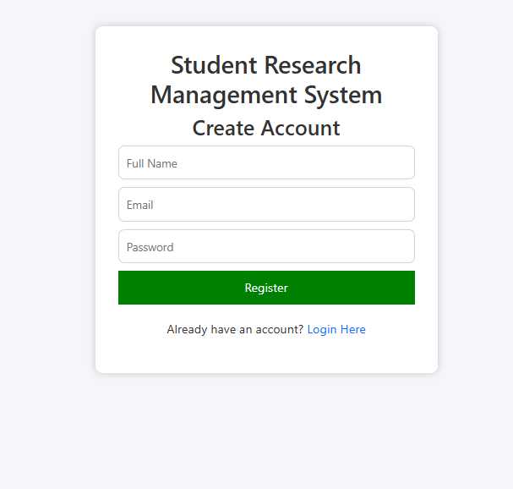
The Registration Page allows new users to create an account by entering their full name, email address, and password. The system validates the information, encrypts the password, and stores the user details securely in the database.

THE LOGIN PAGE
The Login Page allows registered users to access the system using their email address and password. The system verifies the login credentials and redirects the user to the appropriate dashboard based on their role.
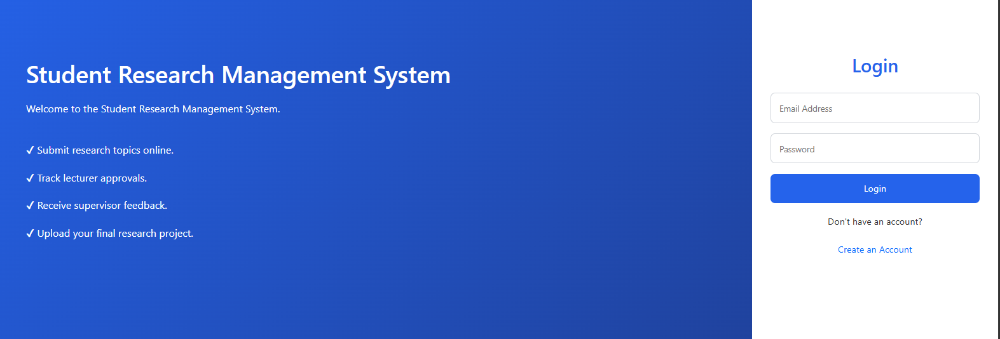

THE STUDENT DASHBOARD
The Student Dashboard provides students with an overview of their research activities. It allows them to view submitted topics, check approval status, see assigned supervisors, receive feedback, and monitor final submissions.
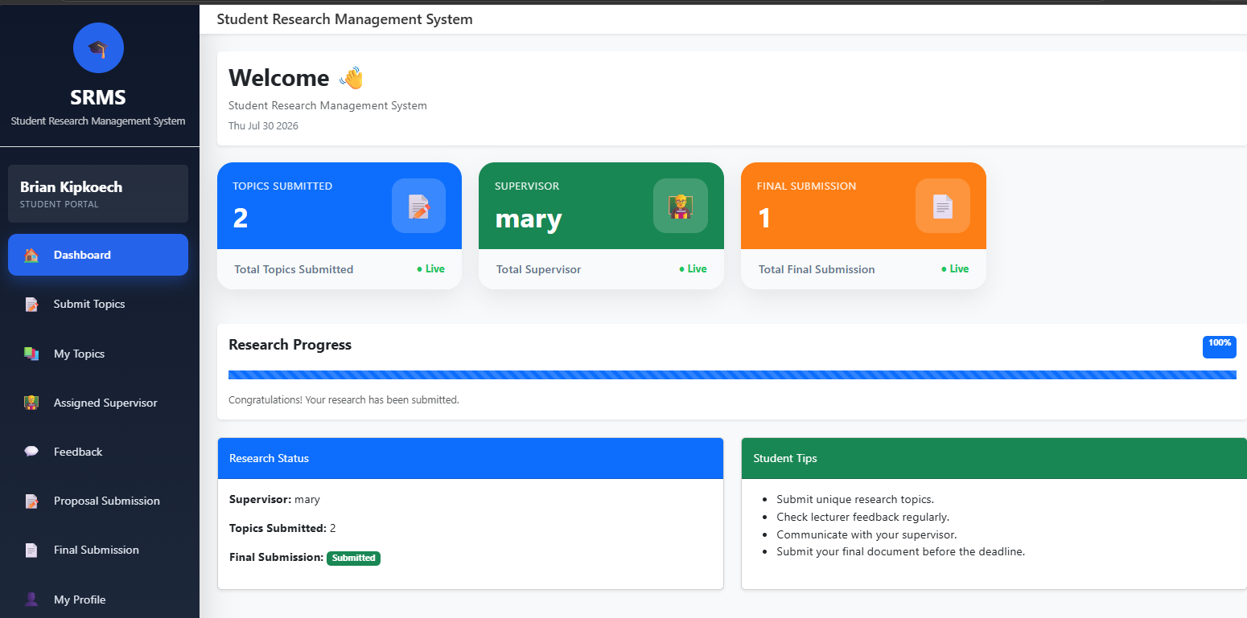

THE SUPERVISOR DASHBOARD
The Supervisor Dashboard helps supervisors manage students assigned to them. It provides access to assigned research topics and allows supervisors to review student work, provide feedback, and monitor research progress.

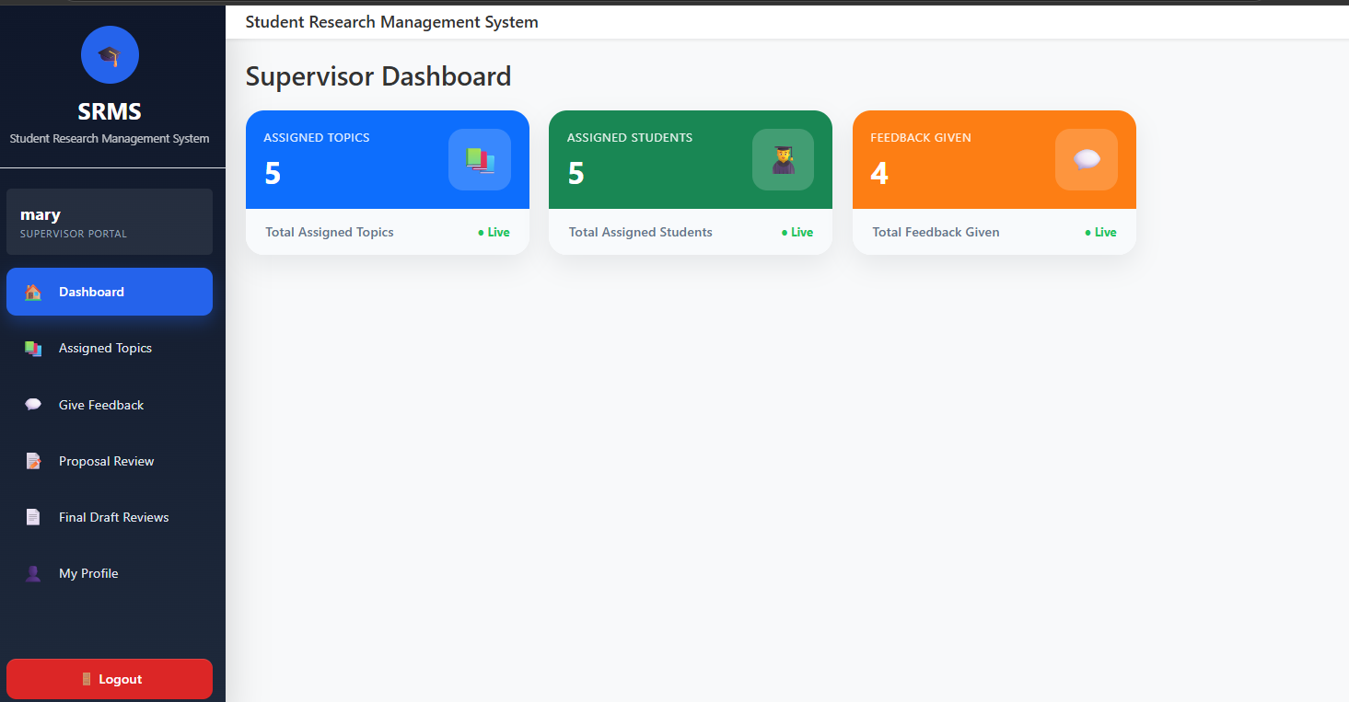

THE LECTURER DASHBOARD
The Lecturer Dashboard enables lecturers to manage and monitor student research topics. It allows them to review submitted topics, approve or reject proposals, provide comments, and assign supervisors to approved research topics.

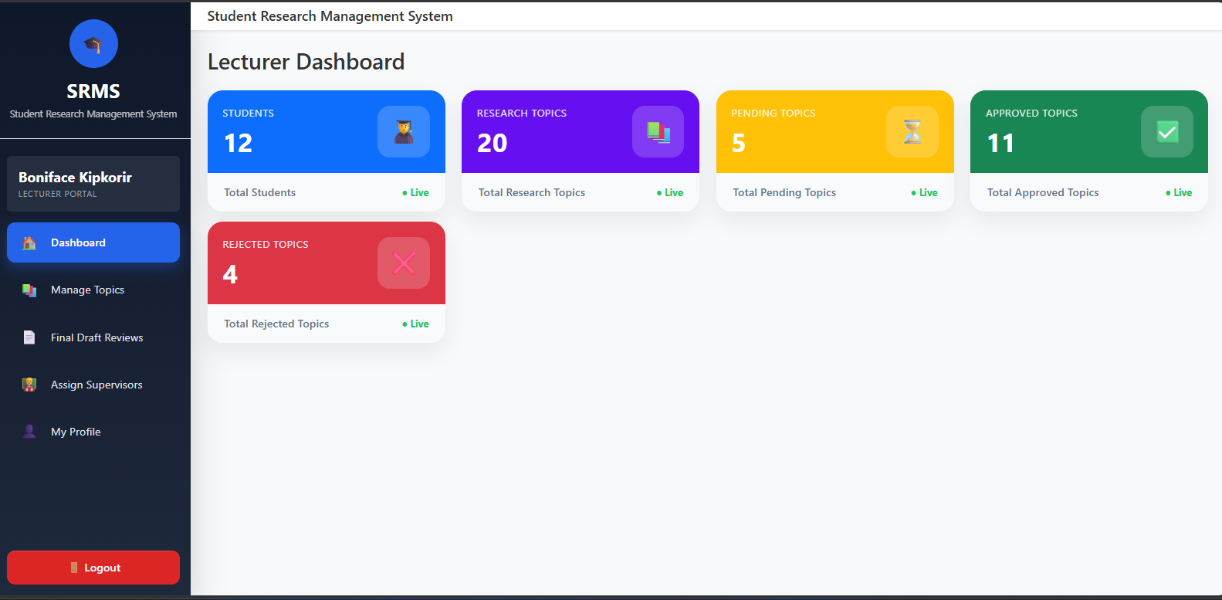

THE ADMIN DASHBOARD
The Administrator Dashboard provides an overall view of the system. It allows the administrator to manage users and roles, monitor research topics, view system statistics, and access final student submissions.
